NAO Education Program – Most Promising Activity of NAO
NAO Education Program
Nepali Association of Oregon (NAO) has an education support program for Nepali youth from the Oregon Nepali Community and the rural communities of Nepal. NAO Education Fund supports qualified young students to complete their high school education and encourages them to participate in the civic and local community programs while helping them become responsible members of their communities.
There are two NAO Education Fund programs:
I. NAO High School Excellence Award Program, and
II. NAO Scholarship Program for genius and needy Students of Nepal
Background
In the fall of 2008, NAO Executive Committee established a $500 High School Excellence Award with the goal of encouraging local Nepali high school seniors to complete their college degree successfully. NAO donated the seed money of $500. An additional $400 was donated by a local philanthropist, Ms. Kinoko Thompson.
The education fund is under the stewardship of NAO executive committee. All donations are deposited in the education fund account, which is kept separately from other NAO accounts. The money from the education fund cannot be used for any other NAO activities. The fund is audited at the time of NAO account audit and the report is made public.
Sources for NAO Education Fund:
1. Donations from the community members and friends of Nepali community in Oregon,
2. Contribution of 25 percent of net profit from all NAO events,
3. Match donations from business organizations on behalf of their employees’ contribution or their voluntary work in the community, and
4.Various fundraising programs such as raffle draw, momo event, or cultural programs, etc.

NAO High School Excellence Award:
NAO awards $500 High School Excellence Award to one high school senior from the Nepali community of Oregon and southwest Washington every year. The award winning student is selected on the basis of high school GPA, community services record, teacher’s recommendation letter and a 700 hundred words essay on the given topic. This program was started in 2010 and 9 students have received this award so far as follows:
Year | Name of Student | College after High School
2018 | Ishu Poudyal | University of Washington, WA
2017 | Aeijan Bajracharya | Oregon State University, OR
2016 | Sandesh Banskota | University of Virginia, VA
2015 | Prowschal Mahato | Oregon State University, OR
2014 | Yashaswi Bajracharya | Oregon State University, OR
2013 | Swechya Banskota | Oregon State University, OR
2012 | Subret Aryal | Oregon State University, OR
2011 | Aakash D Raghubansh | Occidental College, CA
2010 | Manisha Shrestha | University of Oregon, OR

NAO Nepal Scholarship:

NAO started annual Nepal scholarship program in 2011. The scholarship amount was $300 for a 10th grade student, $250 for a 9th grade student and $150 for a 8th grade student every year until 2013. Beginning from 2014, NAO decided to increase the number of the scholarship recipients but the scholarship amount was decreased to $100 per student. This year, NAO provides the scholarship to 15 students from its regular fund and other four students are selected as personal sponsored by our community members. The following students have received the NAO scholarship in Nepal so far:

Year | Student Name | School | Grade
2018 | Gyalien Sherpa | Janapriya Secondary School, Tapting, Solukhumbu | 10
 | Usmita Magar | Janapriya Secondary School, Tapting, Solukhumbu | 10
 | Sangdorji Tamang | Janapriya Secondary School, Tapting, Solukhumbu | 10
 | NhimaDolma Tamang | Janapriya Secondary School, Tapting, Solukhumbu | 10
 | Nisha Kumari Bhandari | Laxmi Narayan Madhyamik Vidyalaya, Matihani,Mahottari | 10
 | Angmu Sherpa | Ananda Bhairab Ma. Vidyalaya, Mulpani, Kathmandu | 9
 | Uttam Khadka | Ananda Bhairab Ma. Vidyalaya, Mulpani, Kathmandu | 9
 | Pawan Kumar Shah | Ananda Bhairab Ma. Vidyalaya, Mulpani, Kathmandu | 9
 | Sulakshya Bakhati | Chwadi Public Madhyamik Vidyalaya, Bidur, Nuwakot | 9
 | Jyoti Kumari Sah | Laxmi Narayan Ma. Vidyalaya, Matihani, Mahottari | 9
 | Pramisha B.K. | Kirtipur Madhyamik Vidyalaya, Kirtipur, Kathmandu | 8
 | Sumit Sharma | Ananda Bhairab Ma. Vidyalaya, Mulpani, Kathmandu | 8
 | Sachina Lungeli Magar | Mahadev Madhyamik Vidyalaya, Kolputar, Nuwakot | 8
 | Suman Pariyar | Bishwo Rastriya Ma. Vidyalaya, Kirtipur, Kathmandu | 8
 | Gayatri Mahato | Sri Bal Madhyamik Vidyalaya, Biratnagar, Morang | 8
 | Pramila Khatri | Ananda Bhairab Ma. Vidyalaya, Mulpani, Kathmandu | 8
 | Sangita Yadav | Sri Bal Madhyamik Vidyalaya, Biratnagar, Morang | 8
 | Kritika Pariyar | Sri Bal Madhyamik Vidyalaya, Biratnagar, Morang | 8
 | Rista Pariyar | Mt. Glory International Boarding School, Kathmandu | 3
2017 | Dolma Sherpa | Arunodhya Madhyamik Vidyalaya, Kathmandu | 10
 | Nisha Sunwar | Yashasvi Sec School, Sitapila, Kathmandu | 10
 | Tenjung Tamang | Yashasvi Sec School, Sitapila, Kathmandu | 10
 | Rojina Bhujel | Inarwuwa English School, Sunsari | 10
 | Samiksya Dhakal | Inarwuwa English School, Sunsari | 10
 | Chhong Dorjisherpa | Janapriya Secondary School, Tapting, Solukhumbu | 10
 | Gyalien Sherpa | Janapriya Secondary School, Tapting, Solukhumbu | 9
 | Usmita Magar | Janapriya Secondary School, Tapting, Solukhumbu | 9
 | Sangdorji Tamang | Janapriya Secondary School, Tapting, Solukhumbu | 9
 | NhimaDolma Tamang | Janapriya Secondary School, Tapting, Solukhumbu | 9
2016 | Dolma Sherpa | Arunodhya Madhyamik Vidyalaya, Kathmandu | 9
 | Nisha Sunwar | Yashasvi Sec School, Sitapila, Kathamandu | 9
 | Tenjung Tamang | Yashasvi Sec School, Sitapila, Kathamandu | 9
 | Rojina Bhujel | Inarwuwa English School, Sunsari | 9
 | Samiksya Dhakal | Inarwuwa English School, Sunsari | 9
2015 | Bishnu Gahatraj | Mohan Kanya High Sec School, Tansen, Palpa | 10
 | Dolma Sherpa | Arunodhya Madhyamik Vidyalaya, Kathmandu | 8
 | Nisha Sunwar | Yashasvi Sec School, Sitapila, Kathamandu | 8
 | Tenjung Tamang | Yashasvi Sec School, Sitapila, Kathamandu | 8
 | Rojina Bhujel | Inarwuwa English School, Sunsari | 8
 | Samiksya Dhakal | Inarwuwa English School, Sunsari | 8
2014 | Nisha Lama | Shree Bajrabarahi Sec School, Lalitpur | 10
 | Bishnu Gahatraj | Mohan Kanya High Sec School, Tansen, Palpa | 9
 | Rupa Pade | Shree Samahungi Sec School, Foxingkot, Plapa | 8
 | Sangita KC | Shree Janashiddha Sec School, Bhadaure, Kaski | 8
 | Smriti Kunwar | Yashasvi Sec School, Sitapila, Kathamandu | 8
2013 | Radhika Rajbahak | Shree Bajrabarahi Sec School, Lalitpur | 10
 | Nisha Lama | Shree Bajrabarahi Sec School, Lalitpur | 9
 | Bishnu Gahatraj | Mohan Kanya High Sec School, Tansen, Palpa | 8
2012 | Milan Shrestha | Laligurans English School, Okhaldunga | 10
 | Radhika Rajbahak | Shree Bajrabarahi Sec School, Lalitpur | 9
 | Nisha Lama | Shree Bajrabarahi Sec School, Lalitpur | 8
2011 | Shrisha Shrestha | Laligurans English School, Okhaldunga | 10
 | Milan Shrestha | Laligurans English School, Okhaldunga | 9
 | Radhika Rajbahak | Shree Bajrabarahi Sec School, Lalitpur | 8

NAO supports schools in Nepal:
NAO started to support for school infrastructure development projects in Nepal after the devastating earthquake of 2015. NAO supported for the school infrastructure development projects of Janpriya School in Tapting, Solukhumbu ($10,000); Bhotenamlang School, Sindhupalchok ($5,000.00); Janabhabana Secondary School, Jyamrung, Dhading ($15,000.00); and Neel Saraswoti Middle School, Nuwakot ($12,000.00) in the last three years. NAO supported for computer lab class development project ($10,000.00) to Bal Vikash School, Balaju, Kathmandu early this year. In addition, NAO recently approved the following micro projects to the schools in Nepal and the fund is being forwarded to the schools.

Name of Schools | Projects | Amount $
Himalaya Nimna Madhyamic Vidhyalaya  Bharatpur, Chitwan | Science lab supplies and furniture purchase | 1,490.00
Ananda Bhairab Secondary School  Mulpani, Kathmandu | Montessori class improvement | 1,000.00
Fultekra Secondary School  Nepaljung, Banke | School toilet renovation | 1,250.00
Kirtipur Secondary School  Kirtipur, Kathmandu | Science lab renovation and laboratory supplies purchase | 1,597.00
Shree Bal Secondary School  Biratnagar, Rani, Morang | Muliti media Class room - Computer and projector purchase | 1,350.00
Shree Madhadev Sceondary School, Kolputar,Belkotgadhi, Nuwakot | Muliti media Class room --- Computer and projector purchase | 1,000.00
Devisthan Secondary School | Microscope-2, furniture and books purchase | 1,000.00
Gandhi Aadarsha Madhyamik Vidhyalaya Manohara, Kathmandu | Montessori class upgrade and supplies purchase | 1,123.00
Total | Approved | 9,810.00
NAO Approved the Micro Projects to Schools in Nepal for the Year 2018
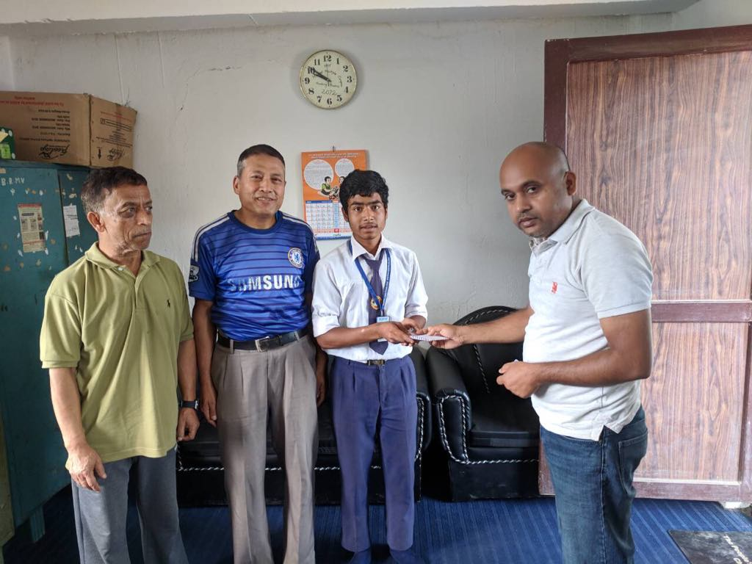
Picture: NAO Treasurer Manish Karn Handing out NAO Nepal Scholarship $100 to Suman Pariyar, a 8th grade student at Bishwo Rastriya Madhyamik Vidyalaya in Kirtipur, Kathmandu, August, 2018.

